Move to the Music was developed by students at University of North Carolina at Chapel Hill. All Rights Reserved. You may freely copy and distribute this game without cost. If you have any questions send email to Gary Bishop gb@cs.unc.edu.

Move to the Music Guide Index
Installing 2
Running the Game 4
Adding Your Music 5
Playing Move to Music 6
Controls 6
Navigation 7
Login menu 9
Setup menu 10
Single player menu 11
Songs menu 12
The Game 15
Game over 16

Installing
- Put the “Move to the Music” disc into your disk drive
- Click on “Start”, then “My Computer”
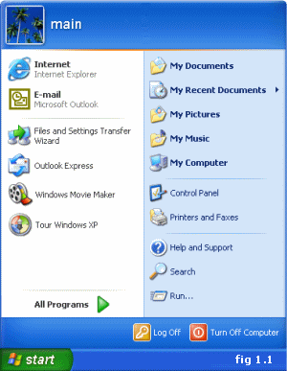
- Double click on the CD drive
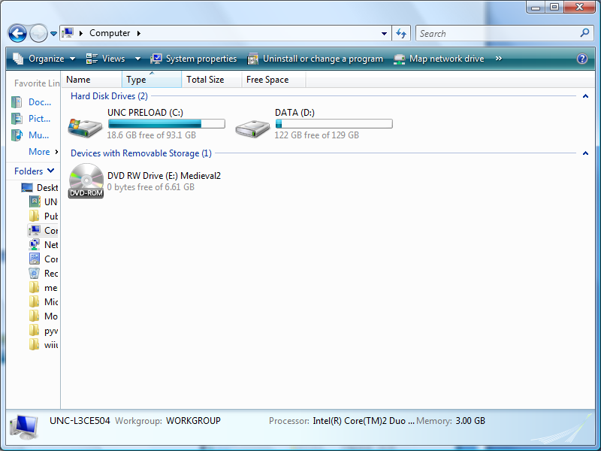
- There should be a single folder. You can “Copy” and “Paste” the folder anywhere on your computer such as the Desktop. You can also drag the folder.
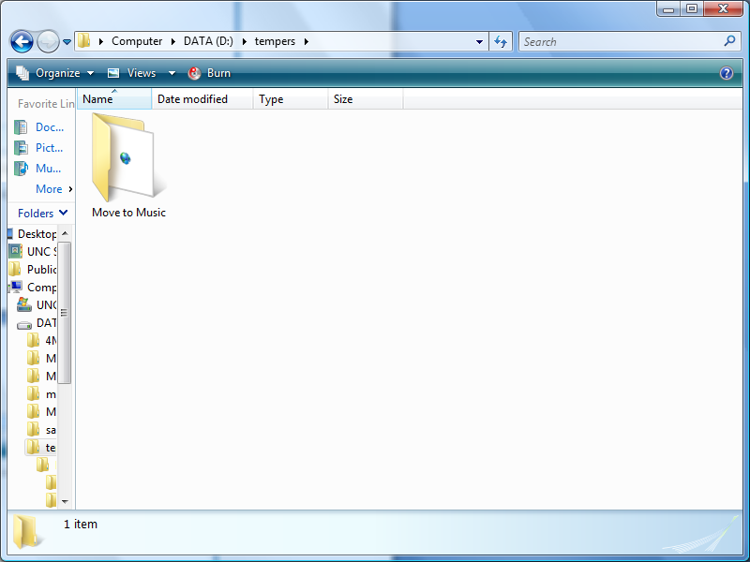
- Do not run “Move to the Music” from the CD, you must copy it to your computer first

Running the Game
- After the game has been copied to your machine, simple double click the “Move to Music” folder

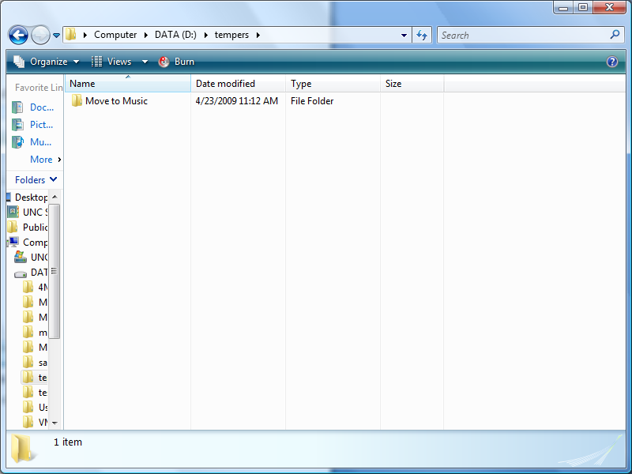
- There should be two folders and a shortcut.
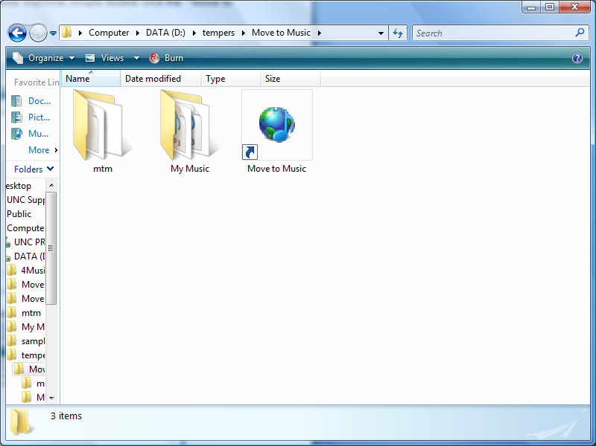
- To start the game double click the “Move to Music” icon
- HAVE FUN!
Adding Your Music
NOTE: Due to compatibility problems all music you wish to use for “Move to the Music” must be in .mp3 format. If the files are in a different file format, you must convert them before adding them to the game. If you are in a game and want to stop pres “Escape” on the keyboard
- After the game has been copied to your machine, simple double click the “Move to Music” folder. There should be two folders and a shortcut.
- Double click on the “My Music” folder.
- Copy any .mp3 files to your this folder.
- When you play “Move to the Music” again, the songs will be added to your “My Music” playlist

Playing Move to the Music
Controls
- Move to the Music is meant to be played on a “Dance Dance Revolution” pad
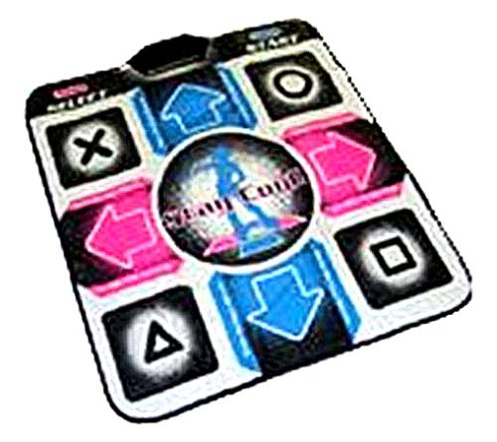
- The game is played by stepping on the 8 different buttons on the map. Each button is a different “step” that the player can do.
- A player can also use the keyboard.
  - The “Q”,”W”,”E” keys correspond to the front row of buttons
  - The “A”,”D” keys correspond to the middle row of buttons
  - The “Z”,”X”,”C” keys correspond to the back row of buttons
  - The “up”, “down”, “left”, and “right” buttons also relate to the corresponding buttons on the dance pad
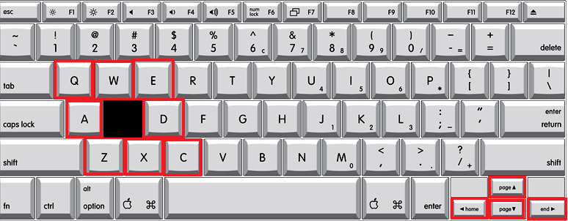

Navigation
NOTE: All navigation is handled through the Left, Right, Front, and Back arrows. To navigate through menu choices, hit Front or Back, To choose the current selected option, hit Right, to go back to the previous menu hit “Left”

- When you first start “Move to the Music” you will be asked if you have played the game before. If you have not hit Left if you have hit Right
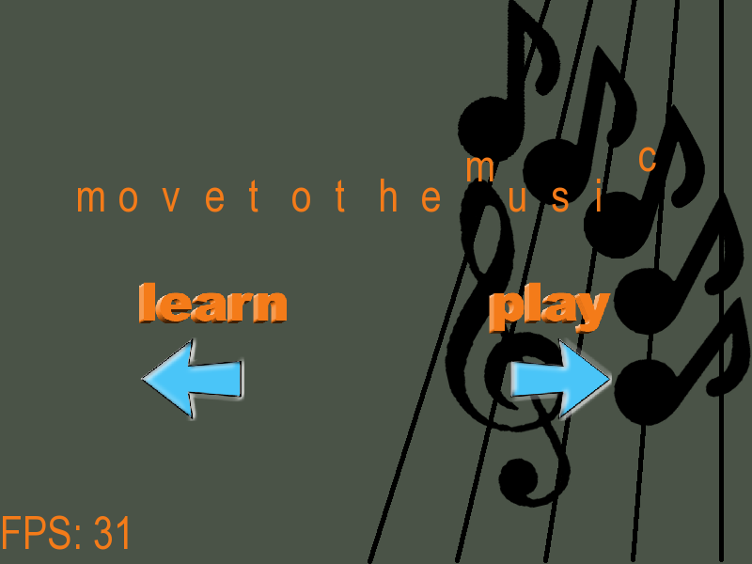
- If you clicked Left you will be taken to the Tutorial section of the game.
The tutorial section has 3 options
  - “How to Play” will explain the basic concepts of “Move to Music”, including navigation and learning to Dance!
  - “Combos” puts you in a real game and demos how to do a step. If you wish to leave this tutorial, hit escape on the keyboard
  - “Done” moves you on to the game
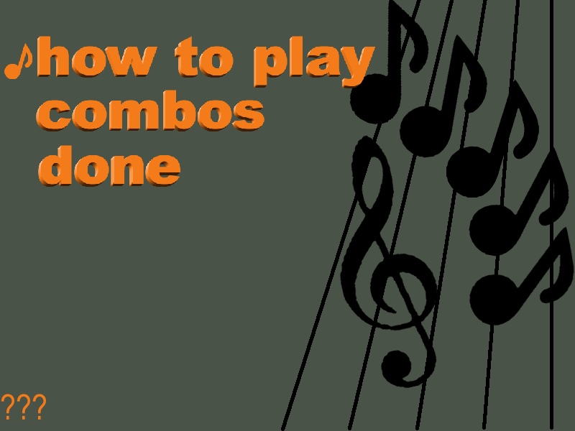
- If you have played before you will be taken to the introduction menu. This menu has 4 choices
  - “Login” allows you to create, load, and delete your very own profile!
  - “Play Now” takes you to the Single player menu, where you will be able to choose what mode you want to play
  - “Setup” allows you to adjust the music, sound effects, and voice volumes, as well as adjusting the resolution
  - “Quit” lets you exit the game
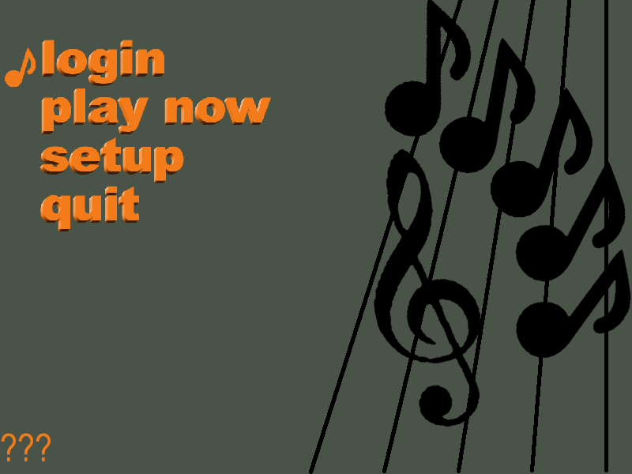
Login Menu
- The Login Menu has 5 choices
  - “My Account” lets you load an already created account
  - “Logout” allows you to log out of the account you have currently selected
  - “Create Account” allows you to create a new account. The name of the account must be unique
  - “Delete Account” allows you to delete any account. You must log out of the account before you do this
  - “Done” takes you back to the “Intro menu”
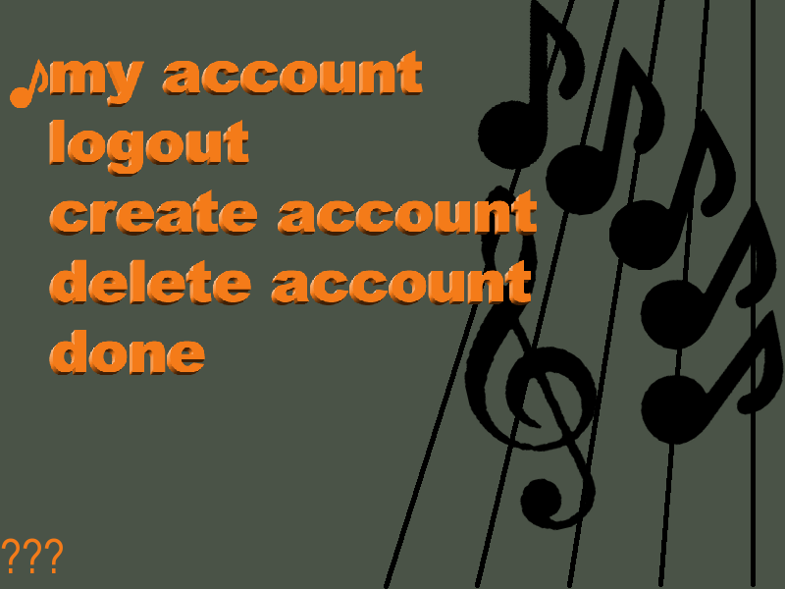
- If you select “My Account”, “Delete Account” or “Create Account” you will be prompted to input a name. A name consists of 3 letters or a “-“.
  - Hitting Right will move you on to the next letter, if you are on the 3rd letter, right will input the name
  - Hitting Left will move you to the previous letter, if you are on the 1st letter, left will cancel your input
  - Front and Back cycle you through the alphabet for the current name you are on
  - Escape on the keyboard will cancel your name input
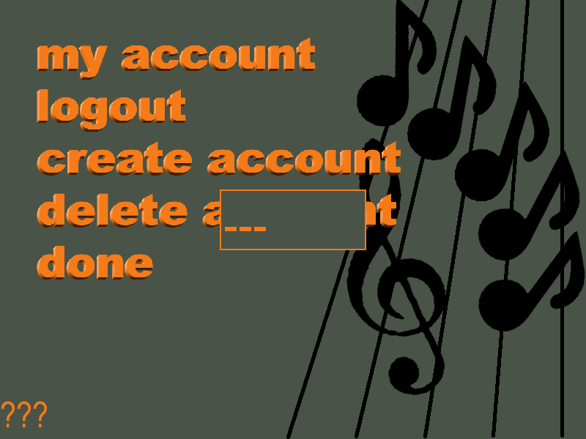
Setup Menu
- The setup menu has 5 choices. Navigate between the choices with Front and Back. To change the current settings, hit Left to decrease the value, and right to increase it
  - Music Volume allows you to adjust the volume of the music played during the game. Can range from 10-100%
  - Music Volume allows you to adjust the volume of the human voices during the game. Can range from 10-100%
  - Sound Effect Volume allows you to adjust the volume of the sound effects played during the game. Can range from 10-100%
  - Screen allows you to adjust the resolution of the screen. The game supports the following
    - 800X600, 1024X768, 1280,960
  - Done takes you back to the Intro menu
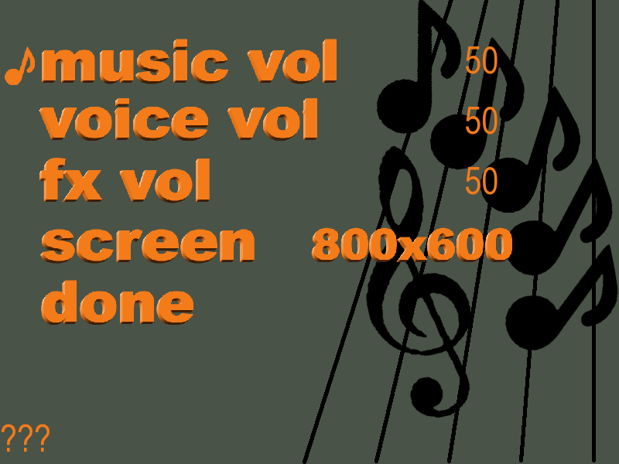
Single Player Menu
- Single player menu has 5 choices
  - Mode – Allows you to switch between “Freeplay” and ”Challenge” modes
    - Free play allows you to do whatever you want and scores you on how well you did.
    - Challenge mode will call out moves for you to do, and as you do them, you can unlock new levels!
  - Difficulty allows you to adjust how hard the game is. It has three settings
    - Easy, tough, and Wicked cruel
  - Play now takes you to the song chooser menu where you can pick which song you want to play
  - My Music takes you to a list of your own music which you will be able to play
    - My Music may take a while to load if you have added new music
  - Done takes you back to the intro menu
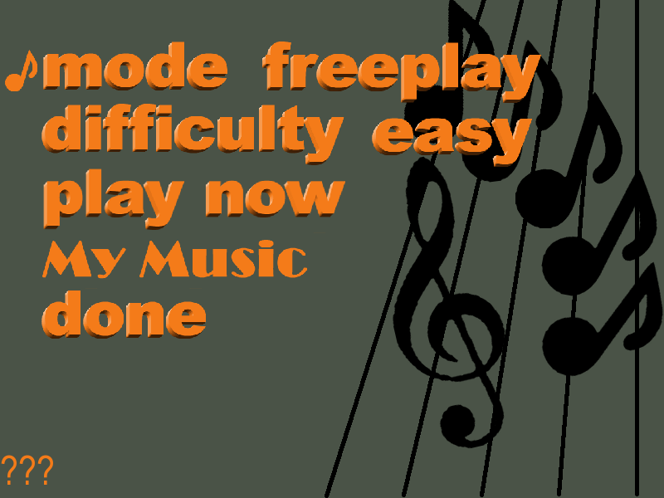
Songs menus
- If you chose to play “freeplay” mode, or you wanted to play with your own music you will be taken to a menu that lists the all of your music. Pressing Front and Back will scroll you through the music choices, Right will play the song. Left will take you back to the Single player menu
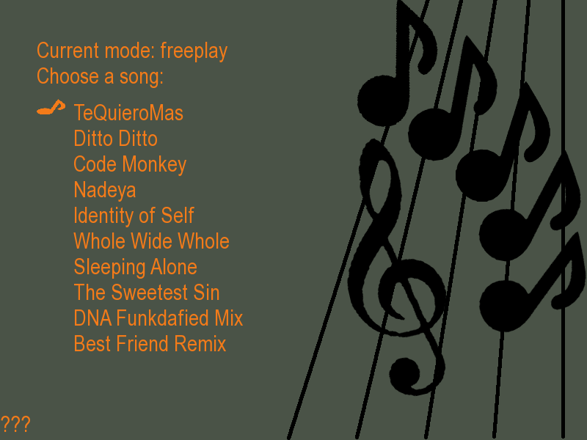
- If you chose to play “challenge” mode, all levels you have unlocked. Pressing Front and Back will scroll you through the levels, Right will choose the level. Left will take you back to the Single player menu

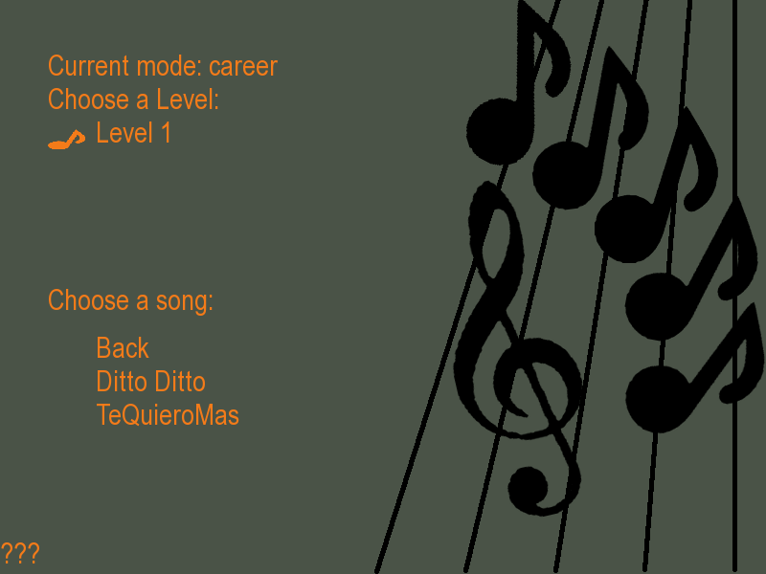
- Once you select a level all the songs on that level. Pressing Front and Back will scroll you through the levels, Right will play the song. Left will take you back to choosing your level

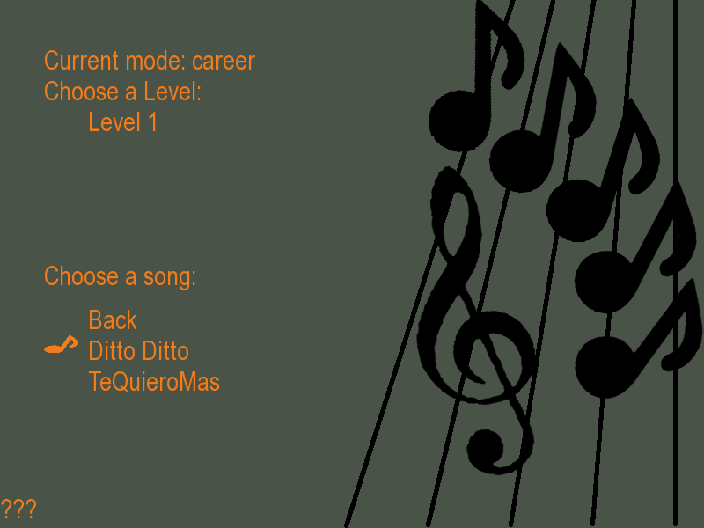
The Game
- As the game starts, you should hear music playing. Step on the pad to the beat of the current song.
  - If you step correctly, you should hear a clapping sound
  - The more steps you hit without missing, the more points you get!

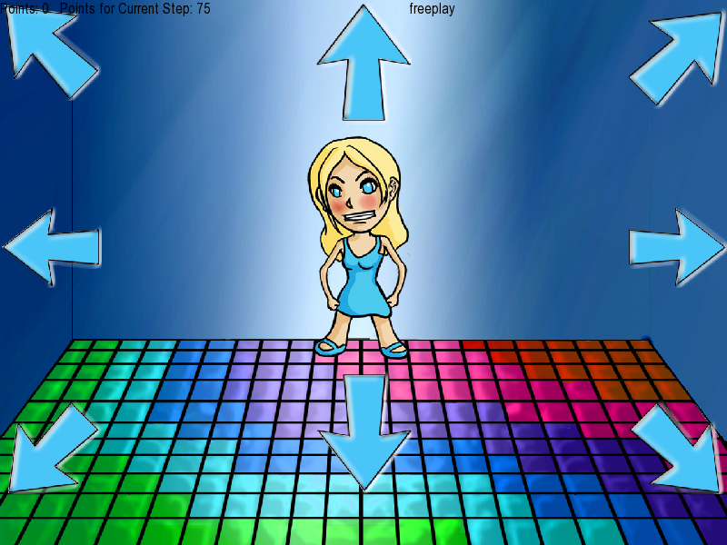
- If you hit a certain series of steps (without miss hitting a beat) you score a Combo. The combos name will be announced, and you rake in the BIG POINTS!
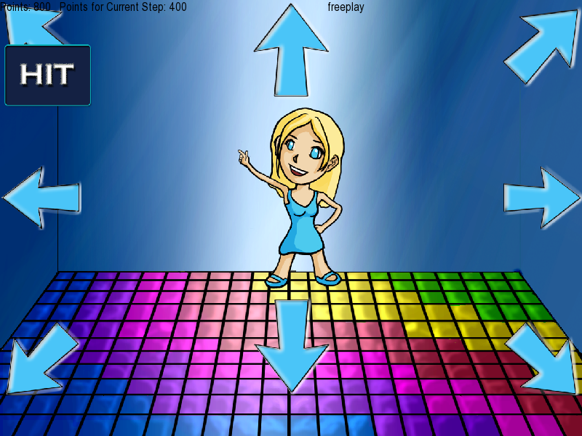
Game Over
- After you have danced your heart out, you can hear how many points you scored. You can also see how your score stacks up to others who played the same song.
- Hitting Left will take you back to the song chooser menu
- Hitting Right while selecting “Done” will take you back to the song choose menu
- Hitting Right while selecting “List high Scores” will list the high scores by any user on the song
- Hitting Right while selecting “Player High Scores” will list your high scores of that song
- Hitting front and down will scroll through the options

